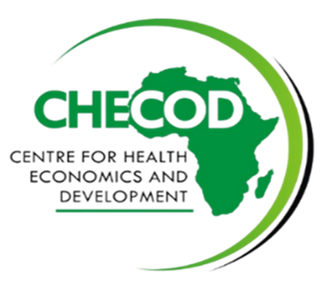

**CENTRE FOR HEALTH ECONOMICS AND DEVELOPMENT**

***Supporting the growth of the health economy***



**Strategic Plan**

**Fiscal Years 2022-2026**

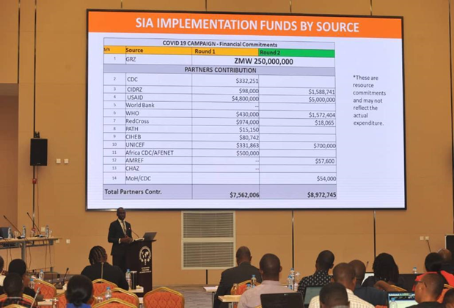



**CHECOD Strategic Plan, Fiscal Years 2022-2026**

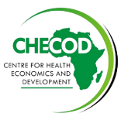

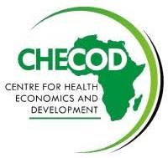**“The Centre aims to provide technical assistance and support to action-oriented interventions on health and economic issues that constrain the equitable delivery of quality health service**”

**Message from the Managing Director**

CHECOD Strategic Plan, Fiscal Years 2024-2030

**CHECOD Strategic Plan, Fiscal Years 2022-2026**



2

**CENTRE FOR HEALTH ECONOMICS AND DEVELOPMENT**

**Strategic Plan for Fiscal Years 2022-2026**

**Executive Summary**



MISSION

To improve health systems development in Africa through health economics and policy-oriented health research, training, knowledge creation, dissemination, and advocacy

To be an international training and technical assistance resource center in health economics and policy analysis for health system improvements and economic development of African countries



VISION

**CHECOD Principles**

To contribute to the growth and application of health economics and development policy research in Nigeria and Africa through;

* Cross-disciplinary collaborations with public and private sectors including related Centres, universities, and research institutions across nations and continents.
* Exchange of inter and intra-continental experiences, ideas, and successes in the area of health economics and health services delivery
* Partnerships and networks with government, academia, private sector, and health care providers, national and international agencies, and organizations engaged in socio-economic development
* Initiatives to address important issues in health care
* Dissemination of information through dialogues, meetings, conferences, and publications in peer-reviewed journals and books

**CHECOD Goals**

CHECOD Goals pursue its medium-term and long-term targets

**Goal 1**

**Enhance effective organization, staffing, and leadership**



**Goal 2**

**Strengthen our research capacity and network**



**Goal 3**

**Enhance diversification of research and dissemination**



**Goal 4**



**Strengthen external engagement**

**Goal 5**

**Optimize the use of digital tools to increase visibility and scale up operation**



**CHECOD Strategic Plan, Fiscal Years 2022-2026**



3

**About CHECOD**

Centre for Health Economics and Development is a not-for-profit, non-governmental organization created in 2010 by a group of African multidisciplinary professionals. The Centre was created to promote greater and more effective utilization of indigenous health professionals in national development and to develop capabilities in health economics in the region.

Objectives

i. To develop and strengthen technical capacity in the application of economic analysis to health policy and practice for public and private sector health professionals, health service managers, academicians, and economic and development planners in Nigeria and other countries in Africa.

ii. To undertake policy-relevant research and consultancy services on health economics and development initiatives to guide policymakers in ensuring high-quality, cost-effective, and sustainable health care.

iii. To provide technical assistance, advisory, and information services to Nigerian governments and semi-government organizations on analysis of the health systems, health policy formulation, and implementation.

iv. To advocate for health systems and economic reforms in Africa with evidence from research in health economics and development.

**CHECOD Pillars**



Engagement

Capacity Building

Research

**CHECOD Strategic Plan, Fiscal Years 2022-2026**



4

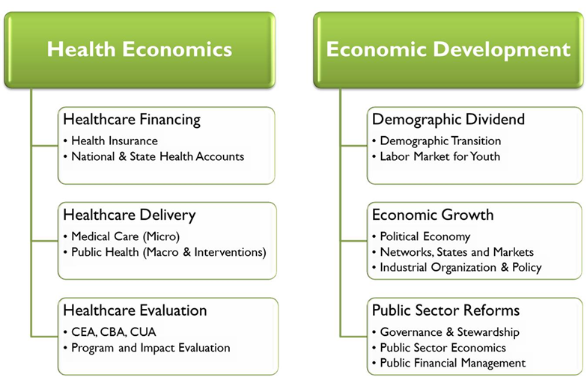**CHECOD Work**

**CHECOD Differentiators**

* Institutionalize health sector planning cell (HSPC) program and built capacity of members.
* Facilitate timely, integrated and evidence-based health planning (strategic and operational), budgeting, implementation, monitoring and evaluation for better health outcomes
* Use spectrum/OneHealth Tool for Cost and Impact evidence generation using whole of system approach
* Use systems of Health Accounts framework and tools for resource tracking and efficiency analysis
* Conduct Value for Money Analysis and Modelling
* Support evidence-based advocacy and integrated health financing for health sector priorities

**CHECOD Key capabilities (National, State, LGA)**

* Health financing analytics and programming
* Public financial management support
* National and subnational health accounts
* Strategic health and Annual Operational Plans
* Economic evaluations and investment case
* Economic modelling and sustainability plans
* Demographic dividends and RMNCH
* Population and institutional-based survey
* Human Resource for Health
* Political economy and policy development/implementation

**CHECOD Strategic Plan, Fiscal Years 2022-2026**



5

**CHECOD Organizational Chart**

We are a team of focused, results-oriented, highly motivated, and talented individuals who are driven by a quest for efficiency in public and private resource allocation. Our background training is diverse, including the natural sciences, engineering and mathematics, health sciences, social and behavioral sciences, and accounting and finance. To meet the needs of our policy environment, we emphasize contextual knowledge in our research, training, and capacity-building programs.

**CHECOD Strategic Plan, Fiscal Years 2022-2026**



6

**CHECOD THEMATIC AREAS**



Leadership and Governance



Health Planning, Budgeting, and Finance



Resource Tracking



Performance Review and Evaluations



Human Resource for Health

Research



Demographic Dividends and Economic Development



v

**Selected Track Records of CHECOD**

**CHECOD Strategic Plan, Fiscal Years 2022-2026**



7

|  |  |  |
| --- | --- | --- |
| **S/N** | **ASSIGNMENT** | **EVALUATIONS** |
| 1. | Economic Evaluation: Cost Benefit Analysis of the National Health Bill  **Client**: Save the Children, Nigeria (2014) | Evidence showed a reduction in out-of-pocket costs over a period of time, long-term savings by the Federal Government, and the number of pregnant women and children under 5 lives saved. The findings had substantial influence in persuading the President of the Federal Republic of Nigeria to sign the National Health Bill into law with the provision of not less than 1% of the Federal Government Consolidated Revenue Fund as Basic Healthcare Provision Fund (BHCPF). |
| 2. | Production of National Health Accounts (NHA) analysis of expenditures by levels of service delivery including health facility survey across the six geopolitical zones (NHA 2010 till Date)  Development of State Health Accounts in Anambra (2010-2021), Sokoto (2015-2021), and Imo (2010-2017) States including health facility survey  **Client**: World Health Organization/Federal Ministry of Health (2014 till Dates) | Federal and State Ministries of Health intensified efforts on Social Health Insurance and Primary Health Care (PHC) Revitalization in response to the high levels of household out-of-pocket (OOP) expenditures and extremely low share of PHC services expenditures at PHC facilities. The findings revealed that most spending on PHC services occurred at secondary health care level thereby increasing inefficiencies in the health system. Ongoing efforts at the Federal level to condition point of entry into the health system through PHC facilities. Examples include the BHCPF program, 1 functional PHC per ward project attracting increased allocation of Federal Ministry of Health to PHC level of care, SOML, etc. |

|  |  |  |
| --- | --- | --- |
| **S/N** | **ASSIGNMENT** | **EVALUATIONS** |
| 3. | Lead Consultant for the Feasibility Studies on the Community Based Insurance Scheme in Nigeria including Health Facility Assessment covering one LGA per State for the 36 States plus the Federal Capital Territory  **Client**: National Health Insurance Scheme (2012-2013) | The findings of the study demonstrated the sustainability challenges associated with CBHIS led to the initiation of the Stated Supported Health Insurance Scheme. |
| 4. | Economic and Financial Modelling of the Proposed State Supported Health Insurance Scheme in Nigeria  **Client:** IFC-World Bank Group (2013) | The findings of the study influenced the National Health Insurance Scheme (NHIS) to decentralize the Federally managed scheme across Nigerian States resulting in States Health Insurance Schemes with a budget to provide technical support to the State Schemes. |
| 5. | Fiscal Space Analysis for Health/State Health Insurance Scheme  **Client:** USAID Health Finance and Governance (HFG) project (2016-2018)  Fiscal Space Analysis for Primary Health Care/Routine Immunization/Roll Back Malaria  **Client:** GAVI/Solina Limited and Health Systems Consult Limited (HSCL) 2019 | Government of Lagos, Oyo, Akwa Ibom, Rivers, Cross River, Bauchi, Plateau, Zamfara, Kebbi, and Sokoto states earmarked 1% or 2% of their State Consolidated Revenue Fund to support coverage of vulnerable population groups in the State Health Insurance/Contributory Schemes with a rekindled drive to explore additional resources to the weak fiscal space through the five fiscal room pillars. The study also influences the Ministry of Economic Planning and Budget to increase budgetary allocation to health. |
| 6. | Technical Assistance to the National Health Insurance Scheme (NHIS) in the review, costing, and financial sustainability analysis of its 10-Year Strategic Plan 2021-2030 to facilitate fulfillment of the Presidential mandate to expand coverage of basic healthcare services and financial protection to all Nigerians by 2030. | NHIS is using the profile of implementing strategies, activities, and costs in the strategic plans for the development of their annual operational plans and other planning and budgeting activities for the health insurance coverage including the prioritization of vulnerable pregnant women and children. |

**CHECOD Strategic Plan, Fiscal Years 2022-2026**



8

|  |  |  |
| --- | --- | --- |
| **S/N** | **ASSIGNMENT** | **EVALUATIONS** |
| 7. | Support to FCDO Lafiya programme States in the capacity building of Planning and Budgeting cell members on and development of Annual Operational Plans | Capacity to strengthen the links between policy priorities and the budget and ensure that health budgets reflect strategic health development priorities built and resulted in AOP-informed Budget. |
| 8. | Economic and Financial Modelling for Sustainability of the Kano Contributory Health Scheme.  **Client**: DFID/MNCH2 Project led by Palladium International (2017) | The Management of the Kano State Health System allocated 37% of the Kano State Health Trust Fund to the Contributory Health Scheme for the coverage of vulnerable population groups including children under 5, pregnant women, etc. |
| 9. | One-Health Tool for Costing of 2018-2022 Strategic Health Plans in all Northern States in Nigeria  **Client**: Federal Ministry of Health (2017-2018) | States are using the profile of interventions and costs in the state strategic health development plans (SSHDP II) developed by CHECOD personnel for all the Northern states of Nigeria for the development of their annual operational plans and other planning and budgeting activities for the health system including the prioritization of PHC Revitalization/RMNCH interventions. |
| 10. | Household Health Care Utilization Expenditure and Willingness-To-Pay Analysis.  **Client**: Health Strategy and Delivery Foundation (HSDF), USAID Health Finance and Governance Project, and World Health Organization (WHO) | State Ministries of Health in Sokoto, Kaduna, Imo Anambra, Bauchi, Rivers, and Cross River used the estimates to inform baseline and target setting in their health financing policy and strategy, and the development of the benefits packages offered under their State Health Insurance/Contributory Schemes. |

**CHECOD Strategic Plan, Fiscal Years 2022-2026**



9

**The Strategic Plan Process**

CHECOD developed a strategic plan process via the review of the previous strategic plan, Technical Advisory Board consultation, management team brainstorming sessions, and feedback from staff and partners. The strategic plan's focus is to enhance and strengthen the capacity, accelerate growth, and expand the scope of operation and influence. The planning process and document preparation were coordinated by the planning and monitoring and evaluation team. The management team and departmental heads discussed and reviewed the drafts.

The process began by:

* Performing the SWOT analysis of the Centre
* Reviewing where the Centre is in the health sector policy landscape in Nigeria and other countries in Africa
* Reviewing the previous strategic plan
* Outlining the possible challenges that the Centre could face and the required mitigation strategies to curb the challenges

**Development Approach**

CHECOD made use of a 4-phase approach to develop its strategic plan.



Priorities Identification

Data Collection and Feedback

Plan Draft and Review

Launch Plan

**Priorities Identification**: Engaged the Technical Board and Management team to identify the priorities and goals of CHECOD to achieving its vision



**Data Collection and Feedback**: Performed SWOT analysis of the Centre, carried out management brainstorming sessions, gather information from staff and partners through surveys and feedback sessions.

**Plan Draft and Review**: developed plan draft. Shared draft with staff for additional input. Management team reviewed the draft.



**Launch Plan**: Assigned implantation responsibility to staff. Established implementation track progress



**CHECOD Strategic Plan, Fiscal Years 2022-2026**



10

**Strategic Plan: Goal 1**



**Enhance effective organization, staffing, and leadership**

In the quest to remain at the forefront in the application of economic analysis to health policy and practice to ensure equitable delivery of quality health services, CHECOD strives to strengthen the management team and workforce by building and improving their capacity and equipping them with the trends, and technical skills needed to surmount the challenges and ensure CHECOD remains the major player in the health economics space.

|  |  |
| --- | --- |
| **Objectives** | **Key Actions** |
| 1.1 Improve leadership capacity | 1.1.1 Review and update the organizational structure and a functional staffing system that supports the main activity areas of the Centre  1.2. Establish a professional development program across the units of the Centre including mentoring |
| 1.2 Enhance CHECOD management workforce | 1.2.1 Conduct annual work plan and performance review across the functional units  1.2.2. Secure stable, diverse, and growing funding for the Centre through maintenance and expansion of existing contract funding sources  1.2.3 Strengthen the management- staff open door policy to enhance communication |
| 1.3 Improve workforce capacity1 | 1.3.1 Provide essential facilities and equipment to produce outstanding knowledge outputs and effective engagement.  1.3.2 Enhance staff and job knowledge and technical skills through periodic capacity building periodic training.  1.3.3 Perform monthly staff performance using the KPIs framework |

**CHECOD Quick Wins:**

**Effective Internal Communication and Staff Capacity Building**

Effective communication and adequate staff technical skills are integral to achieving the vision of the organization. CHECOD enhances communication and capacity building by:

* Using Top-Bottom communication approach to update staff on activities via the official email
* Regular staff capacity-building training
* Departmental biweekly meetings
* Monthly submission of Timesheet
* Staff report on facilitated workshop and training sessions
* Review of staff performance by partners



**CHECOD Strategic Plan, Fiscal Years 2022-2026**



11

**Strategic Plan: Goal 2**

**Strengthen our strong research capacity and network**



To achieve its efficacy and vision, CHECOD endeavors to enhance the built research capacity and network that will accelerate growth.

|  |  |
| --- | --- |
| **Objectives** | **Key Actions** |
| 2.1 Enhance research capacity | 2.1.1 Define research priorities based on extant and emerging development challenges and policy-relevant issues arising from stakeholder engagement in policy and development forums  2.1.2 Expand the space for research collaborations through partners in the private sector, public sector, and non-governmental organizations  2.1.3 Introduce the Centre to the research departments of local and international development organizations for potential collaboration and exchange  2.1.4 Establish a review mechanism for the Centre's research outputs through members of the Technical Advisory Board or other suitably accomplished academic and policy experts in the fields  2.1.5 Attract and retain high-quality staff and fellows to strengthen research capacity and leadership  2.1.6 Create opportunities for students to use resources at the Centre in the conduct of thesis and research projects  2.1.7 Generate publications quarterly in thematic areas that bring to bear the strength of the Centre and align with development policy focus |
| 2.2 Improve network relationship | 2.2.1 Leverage relationships with national statistical agencies and development institutions to expand and improve research as well as source data and potential collaborations  2.2.2 Actively engage the Centre's non-resident associates in the Centre's research pillars and thematic areas and create active links between the resident and nonresident members of the Centre  2.2.3 Register and connect the Centre with local and international health research organizations and participate regularly in academic and policy conferences  2.2.4 Regular participation of the Centre in local and international conferences on health policy |

**CHECOD Strategic Plan, Fiscal Years 2022-2026**



12

**Strategic Plan: Goal 3**

**Enhance diversified research and dissemination**



Research, being one of CHECOD's pillars is germane to its modus operandi. CHECOD ensures the assessment and improvement of its portfolio by equipping and enhancing its capacity with the latest in the health policy space

|  |  |
| --- | --- |
| **Objective** | **Key Actions** |
| 3.1 Ensure research and dissemination success rate | 3.1. Create and grow an earmarked base funding for independent inquiry and related activities  3.2. Access grant funding from local and international development institutions and donor agencies through independent and collaborative research and project proposals  3.3. Increase the number of research calls and produce early draft proposals in response to calls in areas of expertise of staff of the Centre  3.4. Improve the quality and success rate of funding applications from the Centre by engaging strategically with consultant proposal writers and seeking mentoring from more successful grant writers  3.5. Strategically engage members of the Technical Advisory Board and research associates to develop outreach and fund-raising programs and improve sourcing and success rates in funding calls  3.6. Increase efforts to identify and target non-traditional, non-conventional, or less popular funding programs and sources |

**CHECOD Quick Wins:**

**Key Contributions to the establishment of States Insurance Scheme and Basic Healthcare Provision Fund**

CHECOD influenced the establishment of State Health Insurance Scheme with budget provision to provide technical support across the 36States in Nigeria in 2013 through the Economic and Financial Modelling of the then proposed State Health Insurance Scheme which ensured the decentralization of the National Health Insurance Scheme thereby increased the access of Nigerians to finance their healthcare.

CHECOD also influenced the signing of the National Health Bill into law by the President in 2014 which facilitated the provision of not less than 1% of the Federal Government Consolidated Revenue Fund as BHCPF thereby increased healthcare provision for Nigerians through the provision of the Cost Benefit Analysis of the National Health Bill.

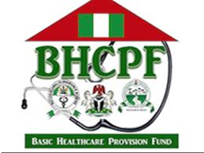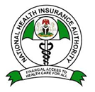

**CHECOD Strategic Plan, Fiscal Years 2022-2026**



**CHECOD Strategic Plan, Fiscal Years 2022-2026**



13

CHECOD strives to remain the focal point in the health economics and development space despite the emerging challenges. CHECOD informs policies that promote health equity by being active in national and international conferences on health economics and development and using standardized analytical frameworks and tools for an integrated, sustainable, and resilient health system

**Strategic Plan: Goal 4**

**Strengthen external engagement**



|  |  |
| --- | --- |
| **Objective** | **Key Actions** |
| 4.1 Enhance collaboration and cooperation | 4.1.1 Create a communication and external relations unit to develop and implement a communication and engagement plan for the Centre  4.1.2 Organize an annual lecture on pertinent health issues in March to commemorate the memorial of the founding chairman  4.1.3 Plan and implement two public seminars annually to present the research and publications of the Centre  4.1.4 Take a more active role in health sector dissemination activities, meetings, dialogues, and conferences  4.1.5 Adopt a targeted approach to external communications locally, nationally, and internationally  4.1.6 Establish strategic partnerships with local and global brands to enhance collaboration, and visibility, and foster projects |

With the desire to achieve its objectives and overcome challenges, CHEDCOD as a resource centre will optimize the use of technology to drive health policy and improve the health systems.

**Strategic Plan: Goal 5**

**Optimize the use of digital tool to increase visibility and scale up operation**



|  |  |
| --- | --- |
| **Objective** | **Key Actions** |
| 5.1 Increase awareness and accelerate operation | 5.1.1 Revitalize the organizational website and use it as an effective tool for engagement and outreach  5.1.2 Create an ICT unit in the organization and equip the unit with the needed tools  5.1.3 Ensure optimum use of the organizational social media handles and invest in search engine optimization to increase visibility  5.1.4 Create a blog post on the website to engage and equip visitors with what the organization is doing and increase their health economics, analysis, and policy knowledge  5.1.5 Develop an email listing of contacts in health research, analysis., dissemination, policy, and development institutions and regularly share insights from the Centre research engagement through a newsletter |

**CHECOD Strategic Plan, Fiscal Years 2022-2026**



14

**Implementation Strategy**

CHECOD ensures its strategic plan aligns with the day-to-day activities of the centre which will drive operation acceleration, foster engagement, increase visibility, and achieve its vision.



**Key Performance indicators**

**Daily Operational Activities**

**Key Activities**

**Objectives**

**Goals**

**Organizational Objectives**

**Mission**

**Vision**

The optimal desire of the organization

Quantifiable metric to measure SP progress

Daily operational tasks that support key activities

Actions required to achieve objectives

Approaches that determine what to be done

Broad statement of the SP that determine achieving the organizational objectives

Broad statement of actions required to achieve the purpose of the organization

The purpose of the organization

**Strategic Plan**

**Operational elements**

**CHECOD Strategic Plan, Fiscal Years 2022-2026**



15

**CHECOD Marketing Strategy**

CHECOD's strategy focus is to improve the health systems and foster economic development in Africa through health economics and policy-oriented research, knowledge creation, dissemination, and advocacy via collaboration and partnership in the health sector. By the provision of technical support in the development, implementation, and sustainability of the Annual Operational Plan at the National and sub-national levels in Nigeria (36 states and FCT) and the institutionalization of the health accounts at both the national and sub-national levels in Nigeria, CHECOD works with the Government, Local Non-Governmental Organizations and International Donor partners in the health sector. Hence, CHECOD's target markets are:

* International health donor partners
* Government Agencies and Parastatals
* Local Non-Governmental Organizations
* Private Consulting Health Organization

Market Definition and Segmentation

|  |  |
| --- | --- |
| **Local Non-Governmental Organizations**   * Society for Family Health * Institute of Human Virology, Nigeria (IHVN) * Education Community Education Welfare Scheme (ECEWS) * Education as a Vaccine (EVA) * Network of People Living with HIV/AIDS in Nigeria (NEPWHAN) * Centre for Population Health Initiatives (CPHI) * Clinton Health Access Initiative (CHAI) | **Government Agencies and Parastatals**   * Federal Ministry of Health * State Ministry of Health * Ministry, Departments, and Agencies (MDAs) * Tertiary, Secondary, and Primary Health Facilities * National Centre for Disease Control (NCDC) * National Action for Control of Aids (NACA) * National Health Insurance Agency (NHIA) * State Health Insurance Agency (SHIA) * National Primary Health Care Development Agency (NPHCDA) * State Primary Health Care Development Agency (SPHCDA) |
| **International Health Donor Partners**   * World Health Organization (WHO) * United States Agency for International Development (USAID) * Global Fund (GF) * Foreign, Commonwealth and Development Office (FCDO) UK-Lafiya project * United Nations International Children’s Emergency Fund (UNICEF) * Global Alliance for Vaccines and Immunization (GAVI) * United Nations Population Fund Agency (UNFPA) * Bills and Melinda Gates Foundation (BMGF) | |

**CHECOD Strategic Plan, Fiscal Years 2022-2026**



16

# Promotional Strategy

CHECOD services will be promoted using the following methods:

* Stands Display in Health Conferences and Workshops
* Brand promotion through policy briefs
* Health publications and health services deliverables
* Advertisements in local publications
* Advertisements in National daily newspapers
* Application for Request for Proposals (RFPs)
* Expression of Interests (EOI)
* Request for Information (ROI)
* Invitation to Bid

# Communication Strategy

CHECOD will communicate her activities via her social media platforms (X formerly Twitter, LinkedIn, and Facebook) and engage with partners and clients on the website to create awareness and enhance marketing. The platforms (social media handles and website) will be used to give reports of the organization's activities and facilitate community engagement.

# Competition Strategy

CHECOD primary competitors are the Health financing consulting organizations. CHECOD plans to beat competitors through consistent quality and timely delivery of services which are the yardsticks clients use in the health consulting industry, and by facilitating and honing healthy networking in the health sector.

**CHECOD Strategic Plan, Fiscal Years 2022-2026**



17

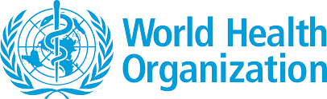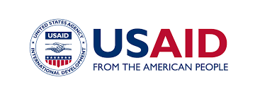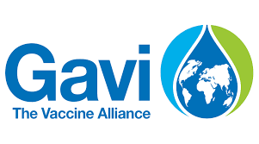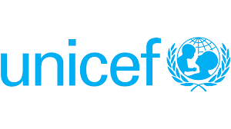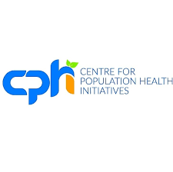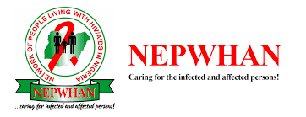

**Appendix A**

**CHECOD Partners**

CHECOD leverages on formal collaborative relationships with several institutions relevant to the health sector. CHECOD strategic plan encourages fostering relationships with existing and new partners via connection and cooperation. These include:

**CHECOD Strategic Plan, Fiscal Years 2022-2026**



18



**Our Technical Advisory Board**

**Appendix B**

**CHECOD People**

CHECOD resource persons include health economists, development economists, health scientists, statisticians, and information systems specialists.



Prof. Eyitayo Lambo

*Former Honourable Minister of Health,*

*Federal Republic of Nigeria*



Prof. Adedoyin Soyibo

*Former Director of Health Policy Training and Research Program*

Prof. Olayemi Omotade



*Director of the Institute of Child Health,*

*College of Medicine, University of Ibadan*

*Monitoring and Evaluation Advisor at PATHS2*

Dr. Ibrahim Ozovehe Yisa



*Former CMD, Lagos University Teaching Hospital*

Prof. Akin Osibogun

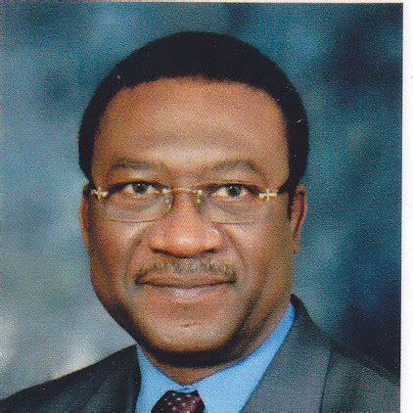

Dr. Kenneth Ojo (Deceased)

*Founder, CHECOD*



**CHECOD Strategic Plan, Fiscal Years 2022-2026**



19

Mrs Veronica Oyekemi Ojo, RN

*Secretary to the Technical Advisory Board*



**Management Team**



Oluwole Smile, PhD

*Managing Director*



Olumide Taiwo, PhD

*Executive Director, CHECOD Africa*



Paul Akeni, PhD (*in view)*

*Director, Finance and Administration*



**Head of Departments**

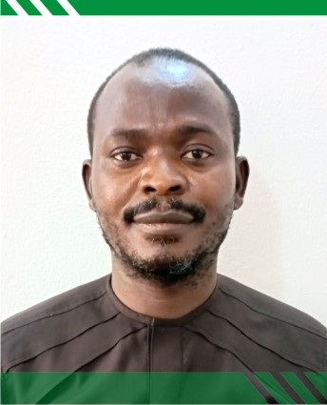

David Attah

Head, Planning, Monitoring and Evaluation Department

Head, Resource Tracking Department

Ubong Ekerete

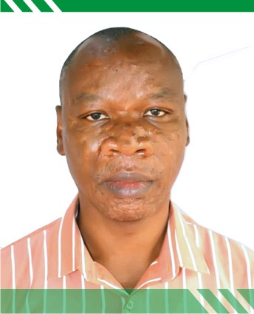

### Emmanuel Ameh

Head, Business and Marketing Department

### Boniface Agbaru

Head, Compliance Department

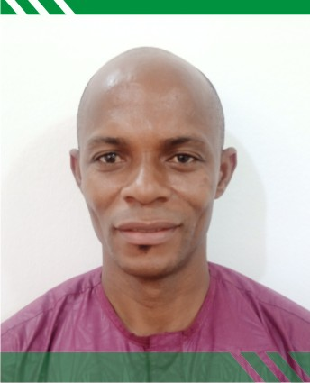

**CHECOD Strategic Plan, Fiscal Years 2022-2026**



20

**Stay Connected**

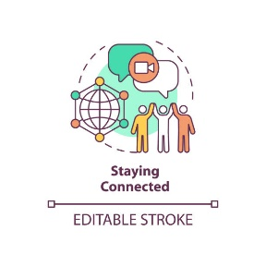

**Appendix C**



**No. 23, I.T Igbani Street, Jabi, Abuja, Nigeria**



**www.checord.org**

**Info@checod.org**



**+2348033005021, +2348060040736**



**Social Media Handles**

**@checodafrica**



**https://www.linkedin.com/company/checod/**



**https://web.facebook.com/checodNigeria**



**Supporting growth of the health economy**

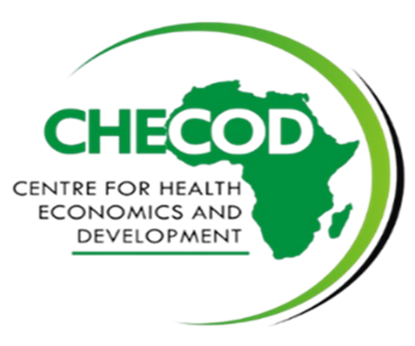

**CHECOD Strategic Plan, Fiscal Years 2022-2026**



21